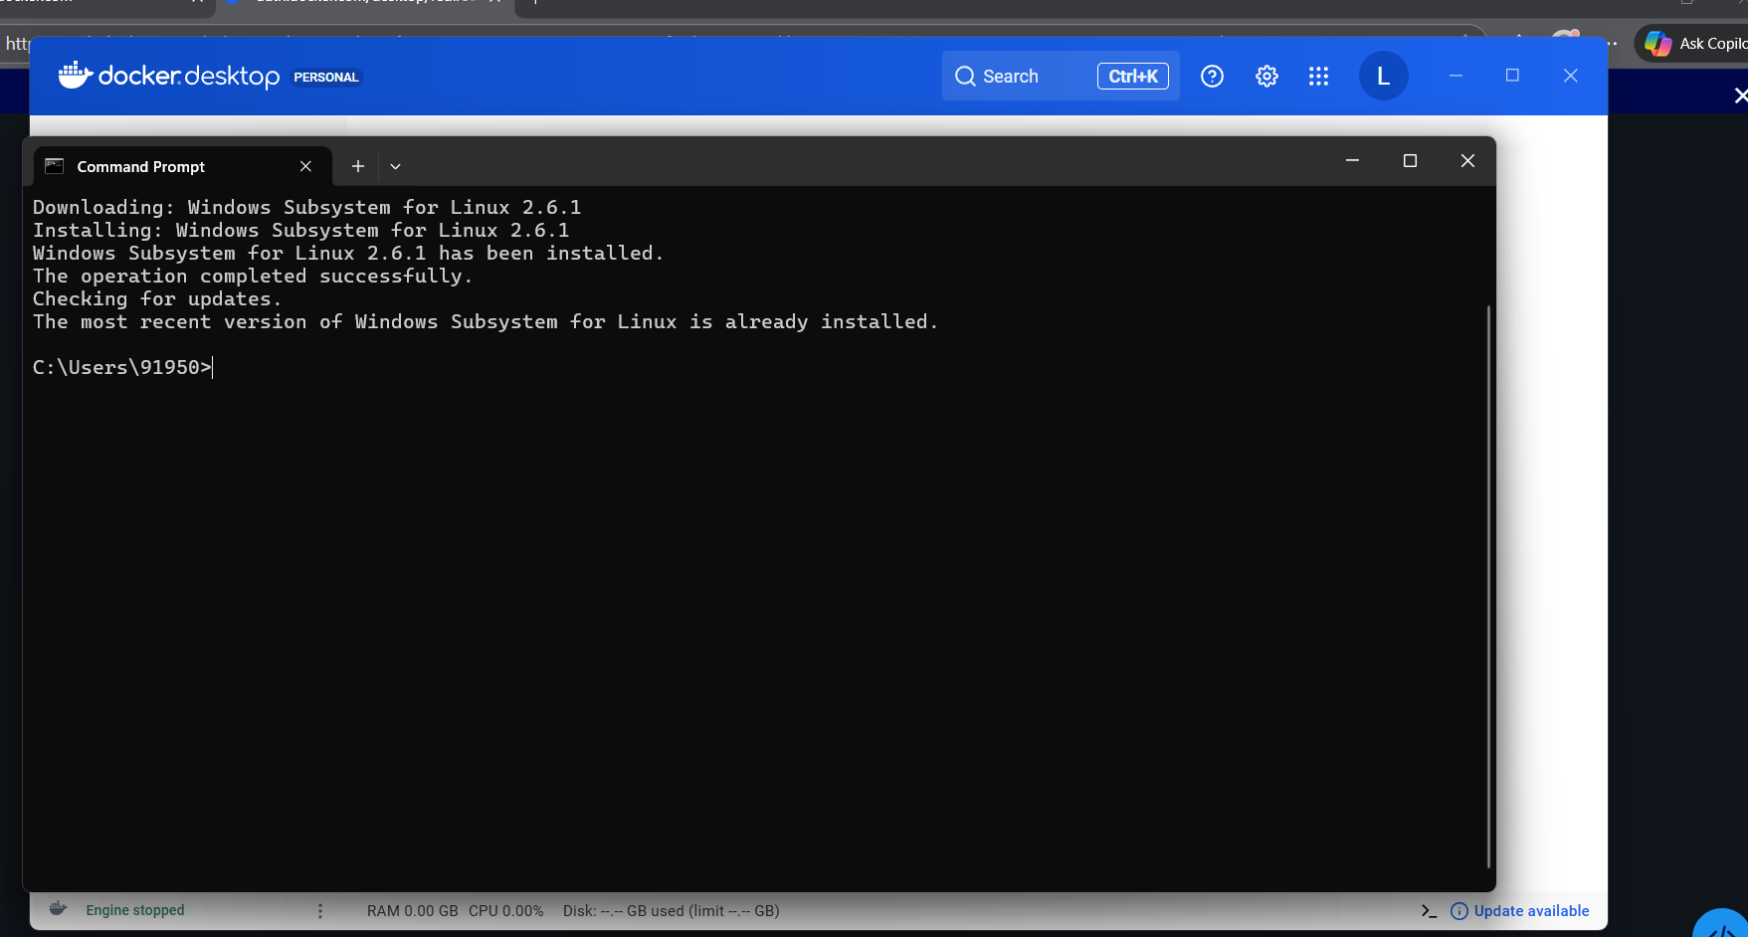
• Update system
sudo apt update -y
• Install Java
sudo apt install openjdk-17-jdk -y
• Create Tomcat user
sudo useradd -m -U -d /opt/tomcat -s /bin/false tomcat
• Download Tomcat
cd /tmp
wget https://downloads.apache.org/tomcat/tomcat-10/v10.1.31/bin/apache-tomcat-10.1.31.tar.gz
• Extract Tomcat
sudo mkdir /opt/tomcat
sudo tar -xvzf apache-tomcat-10.1.31.tar.gz -C /opt/tomcat --strip-components=1
• Give permissions
sudo chown -R tomcat: /opt/tomcat
sudo chmod +x /opt/tomcat/bin/*.sh
• Start Tomcat
/opt/tomcat/bin/startup.sh
• Check if it’s running
Open your browser and go to:
👉 http://localhost:8080
